CHAPTER 1

INTRODUCTION
Introduction typically should have total 3 pages. Its 1st paragraph should start with the industrial applications of your project. Then discuss broad area on which you want to work. Then discuss briefly what exact research you want to do. Finally you can discuss in one paragraph what has been done in literature. Next write what methodology you want to adopt. Finally discuss the organization of your report as for example. Note that in general, introduction should not contain equation.

1.1 Organization of report:
Chapter-1 introduces the system and process responsible for aging and gas formation in transformer. Chapter-2 discusses the literature on the theory of aging of transformer oil. ….. Finally we have concluded the results in chapter -5.
CHAPTER 2
REVIEW OF LITERATURE
Paragraph should start from here. Tell summary of this chapter. Also write such a way that all sections and sub-sections are connected.
2.1 Page Setup and Length of Report
Set page in following format. Go to page layout. Click page setup. Click margins. Select top, bottom and right margins as 1 inch and left margin1.5 inch. Total length of report from introduction to reference should be 25 to 35 pages.
2.2 Paragraph Setup
Paragraph should start here. Set paragraph in following format: 12pt, Times New Roman, Justified. A paragraph should have at least 4 lines. Each line in a paragraph should be separated by 1.5 lines. After each paragraph do not give any extra line space. New paragraph should start 0.5’ in 1st line indentation. After each section there should be 12pt spacing. There should not be any gap in between start of paragraph and heading of section, subsection or sub-subsection. The title of section can be written as “2.1 Section” in 12pt bold, where first number is chapter number and .1 is the section number. The title of sub section can be written as “2.1.1 Equation” in 12pt Italics, where 2.1 is the section number and .1 is the subsection number. The title of sub sub- section can be written as “2.1.1.1 Sub sub section” in 12pt Italics underline, where 2.1.1 is the sub-section number and .1 is the sub subsection number. The title of the front matters should be 16pt bold centered. Gap of 36pt in between the title of the title of the front matters and paragraph. The title of the chapter should be 14pt bold centered. Separation between them should be 18pt. Gap of 18pt in between the title of the chapter/title of the front matters and paragraph

2.2.1Sub Section
Subsection should start from here. The formatting of this section is exactly same as that given in section.
2.2.1.1 Sub sub section: Start sub sub section from this place. Follow exactly the instruction given in description section 2.1.
2.2.2Equation
It is better to use equation editor from insert →object→microsoft equation3.0 Each equation should be numbered like 2.1, 2.2, etc. where 2 is the chapter number and .1, .2, .3 etc are sequence number. As for example see equation 2.1 below.
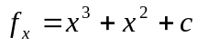 (2.1)
Equation should be right justified, no gap in between paragraph and equation. Font and style of symbols used in equation should be same as that used in text.
2.2.3 Tables and Figures
Refer figure and Table in the running text as shown in example fig 2.1 and table 2.1. A figure should cover at least half a page. It should have number title, which should appear at the end of figure. A table should have number and title as shown in table 2.1. Title should appear at the start of the table.
2.3 Pagination
Every page in the dissertation (except blank pages in the front matter) must be assigned a page number. The page number should be in Arabic, which are to be placed in the upper right-hand corner for all the pages starting with introduction.
Use lower case Roman numerals without punctuation or dashes on all front matter of the dissertation i.e. DECLARATION AND APPROVAL OF SUPERVISOR to LIST OF FIGURES.

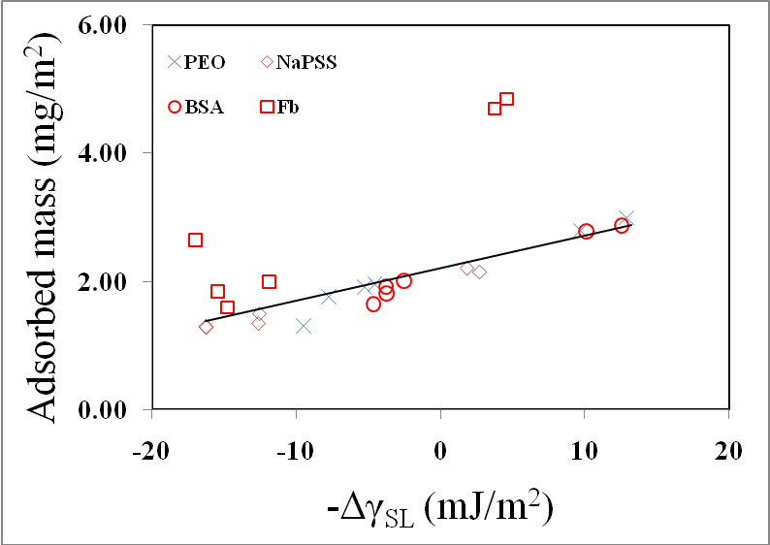

Figure 2.1: Variation of adsorbed amount with wetting tension. The solid curve indicates the theoretical variation, the symbols indicate experimental data points. (Click in paragraph in the word menu. Put 0.9’ in hanging in the indentation)
(Note that justify in the title exactly according to the above example. All lines in the graph will be of thickness 2.5pt. All axes should be labeled with the appropriate label of font size of 18pt)

Table 2.1 : An Example table. Chapter Number and Table Number within chapter

CHAPTER 3

METHODOLOGY

CHAPTER 4

RESULTS AND DISCUSSION

CHAPTER 5

CONCLUSIONS AND SCOPE FOR THE FUTURE WORK

References

Heibel AK, Vergeldt FJ, van As H, Kapteijn F, Moulijn J, Boger T. Gas and liquid distribution in the monolith film flow reactor, AIChEJournal.2003;49:3007-3017.

Ktari N, Quinson J, Teste B, Siaugue JM, Kanoufi F, and Combellas, C. Immobilization of magnetic nanoparticles onto conductive surfaces modified by diazonium chemistry, Langmuir. 2012; 28:12671-12680.

Givan AL. Flow cytometry: first principles (2nd edition). NewYork: JohnWiley & Sons, Inc., 2001.

Luketich JD, Ginsberg RJ. Diagnosis and staging of lung cancer, In:Johnson BE, Johnson DH. Lung cancer. New York: Wiley-Liss,Inc.,1995:161-73.

Follow format of 1&2 to refer to Journals:

Follow format of 3 to refer to Books:

Follow format of 4 to refer to Book Chapters:

APPENDIX-A1: SYMBOLS

SYMBOL | MEANING | UNIT

ARRANGE SYMBOLS USING LATIN ALPHABETS FIRST ALPHABITICALLY. ARRANGE GREEK ALPHABETS ALSO ALPHABETICALLY. WRITE UNITS APPROPRIATELY.

